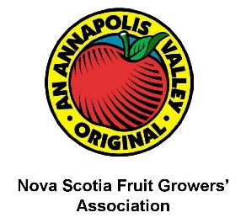

Application for Access to NSFGA Davis Weather-Link
Please fill in as much of the requested information as possible. You will be contacted by the NSFGA if further information is required and to discuss payment of fees (if applicable). At present, access to the NSFGA Davis Weather-Link network provides access to all stations for both real time data and historical data. Please note that the network became active in May 2021.
- Name: Click or tap here to enter text.
- Company/University/Affiliation: Click or tap here to enter text.
- Address: Click or tap here to enter text.
- Email/phone number: Click or tap here to enter text.
- Reason for accessing the NSFGA Davis Weather-Link (click all that apply):
Grower, for production of crop(s) ☐
Research ☐
Extension ☐
Personal use ☐
Other (please specify) Click or tap here to enter text.
- For how long are you seeking access? Choose an item.
- Are you a member of the NSFGA? Choose an item.
- If ‘Research’, please provide the following:
  - Project title: Click or tap here to enter text.
  - Start date of project: Click or tap to enter a date.
  - End date of project: Click or tap to enter a date.
  - Please describe how your project will benefit the apple industry and the NSFGA: Click or tap here to enter text.

Fee structure:
Category | Fee*
NSFGA member, apple-related research project | Free
NSFGA non-member, personal use, non-apple-related research project | $ x/year
*estimated amount, subject to change

